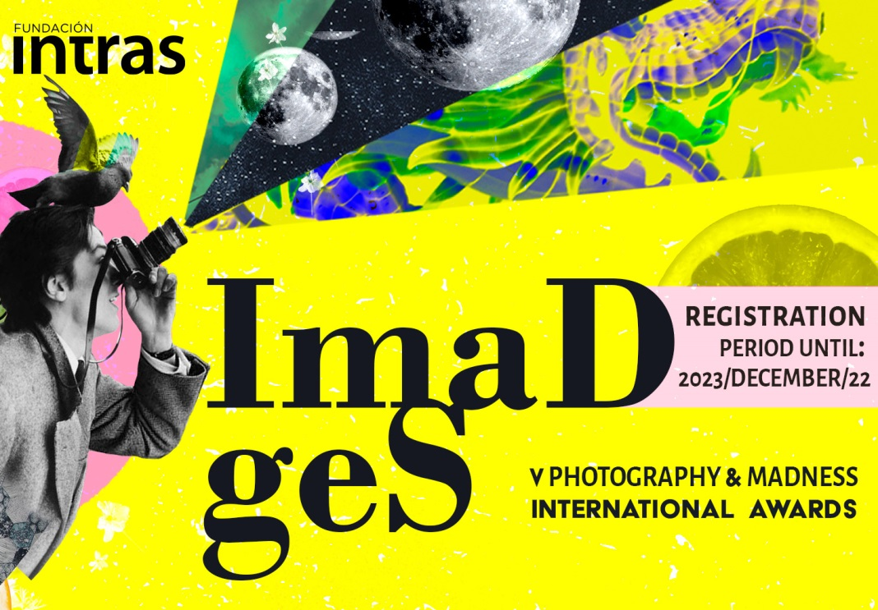

Personal
Full name
ID or Passport |  |  |  | Country
Adress
Town |  |  |  | Province
Phone contact number |  |  |  | E-mail

I wish to participate in the V Photography and Madness International Awards with the work.
Fyle name and work title
Story that accompanie the work (extension: between 500 y 700 caracters without spaces)

☐ I declare that all the works submitted to V INTERNATIONAL PHOTOGRAPHY AND MADNESS AWARD are original and unpublished and have not been submitted to competition or contest before this date

Sing and date

SEND THIS APLICATION FORM:
You can send it by email to : fotos@intras.es or through de We transfer (to the same e-mail)

IT WILL BE ATTACHED :
- work in digital format
- photocopy of ID, passport or equivalent scanned document of the author
- Donation receipt

